**DAILY ONLINE ACTIVITIES SUMMARY**

|  |  |  |  |  |  |  |  |
| --- | --- | --- | --- | --- | --- | --- | --- |
| **Date:** | **29 MAY 2020** | | | | **Name:** | **K.ISHA HEGDE** | |
| **Sem & Sec** | **4th sem A** | | | | **USN:** | **4AL18CS031** | |
| **Online Test Summary** | | | | | | | |
| **Subject** | | **OPERATING SYSTEM(18CS43)** | | | | | |
| **Max. Marks** | | **30** | | **Score** | | **29** | |
| **Certification Course Summary** | | | | | | | |
| **Course** | **INTRODUCTION TO CYBER SECURITY(1hr)**  **CLOUD FOUNDATION(2hr)** | | | | | | |
| **Certificate Provider** | | | **Great learning** | **Duration** | | | **3hrs** |
| **Coding Challenges** | | | | | | | |
| **Problem Statement: 2problems** | | | | | | | |
| **Status: executed** | | | | | | | |
| **Uploaded the report in Github** | | | | **Yes** | | | |
| **If yes Repository name** | | | | **[https://github.com/iishaii/locked-down_coding](https://github.com/iishaii/locked-down_coding" \o "https://github.com/iishaii/locked-down_coding)** | | | |
| **Uploaded the report in slack** | | | | **Yes** | | | |

Online Test Details: (Attach the snapshot and briefly write the report for the same)

Certification Course Details: (Attach the snapshot and briefly write the report for the same)

Coding Challenges Details: (Attach the snapshot and briefly write the report for the same)

**Online Test Summary:**

Today **OPERATING SYSTEMS (18cs43)** was conducted of first module. Total marks for the test was 30

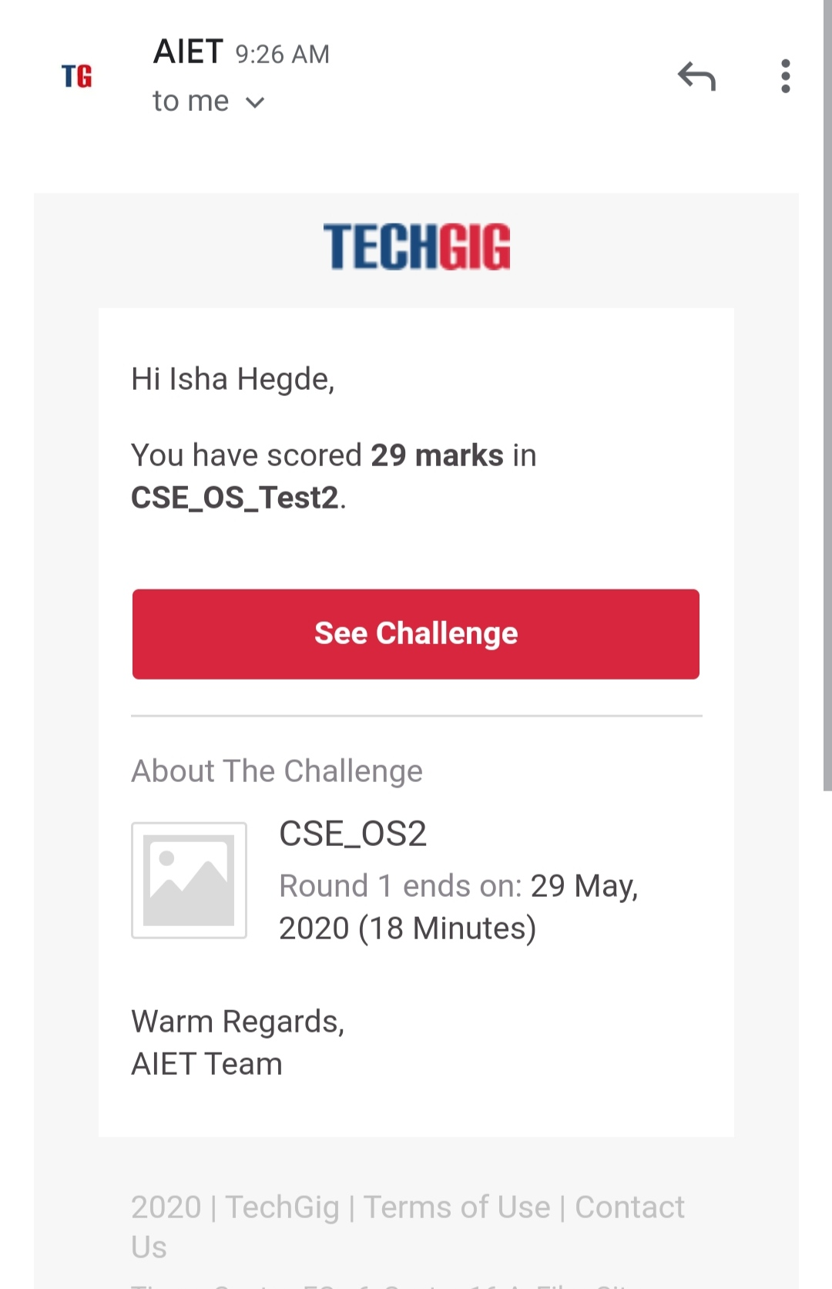

**Certification Course Summary:**

**Today I continued with CLOUD FOUNDATION through Great Learning.**

I completed the ADDITIONAL LEARNING RESOURCES. And also cloud based IOT DEMO.

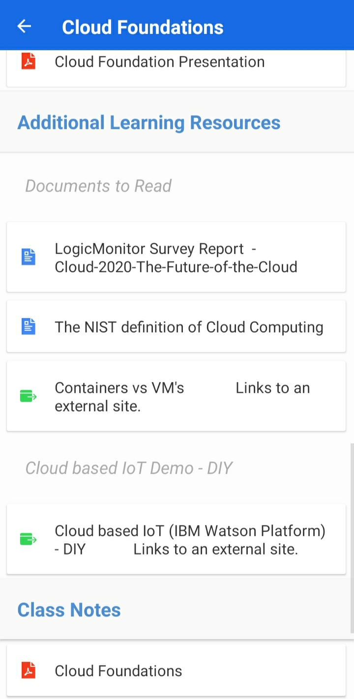

And also continued with INTRODUCTION TO CYBERSECURITY.I covered two topics.

* Introduction to crytography
* Secure system design.

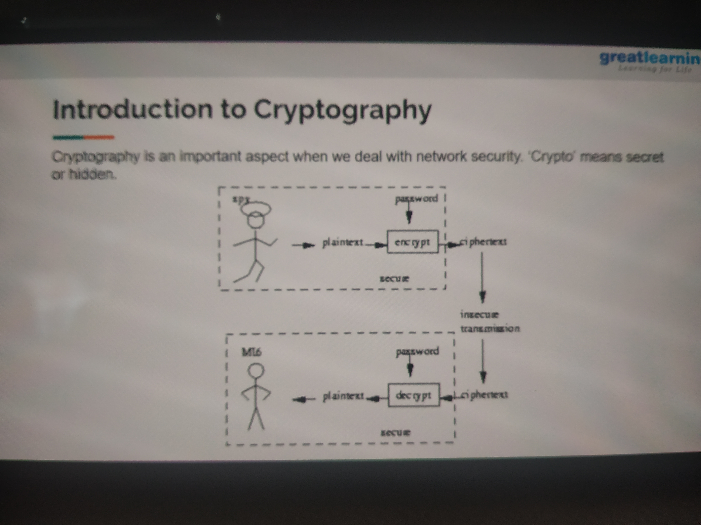

**Coding Challenges:**

Today I solved 2 coding challenge,

Write a C Program to generate first N Armstrong Numbers

Write a Java program to Find size of the largest ‘+’ formed by all ones in a binary matrix

